
PROJECT DOCUMENTATION
Purpose Plan DC/DR

October 23, 2026
BY: Ritesh Chaudhary

Table of Contents
1. Introduction 2
2. Purpose 2
3. System Architecture & Infrastructure Plan 2
3.1 System Architecture Plan 3
3.2 System Infrastructure Plan 3
4. Data Flow and Synchronization Process 4
5. Physical Setup Requirements 4
6. Power, Cooling & Safety Measures 4
7. Benefits of This Project 5
8. Conclusion 5

1. Introduction
This report presents a complete proposal for deploying a small-scale but reliable Data Center (DC) with a mirrored Disaster Recovery (DR) site. The aim is to provide your organization with secure, well-structured IT infrastructure that protects data, ensures system availability, and maintains smooth operations even during unexpected failures. The DR site acts as a fully replicating standby environment that can immediately take over if the main DC becomes unavailable.

2. Purpose
The purpose of building this DC + DR environment is to establish strong operational continuity, eliminate risks of loss, and provide uninterrupted access to business applications. The main DC handles daily workload, while the DR site stays synchronized and available as an emergency backup. In case of hardware failure, power disruption, network outage, or disaster, the DR site automatically becomes active with minimal downtime. This ensures that the organization maintains essential services with full reliability.

3. System Architecture & Infrastructure Plan
This section provides a complete view of both the logical architecture and the physical infrastructure used for the DC and DR setup.
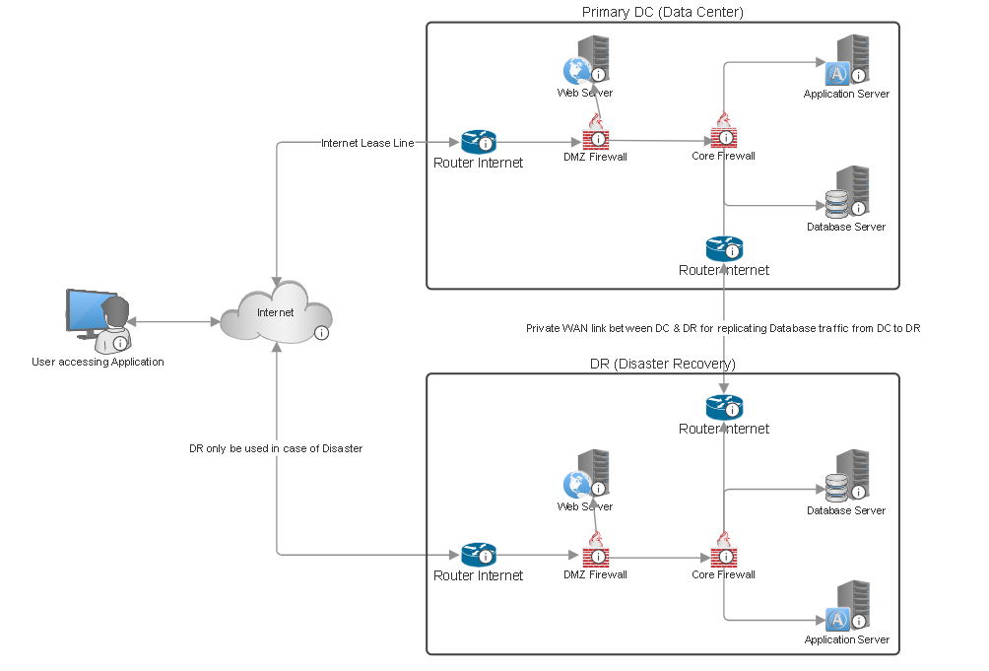
Fig 1: Data Center (DC) and Disaster Recovery (DR) Architecture
The entire architecture illustrates connecting the Primary Data Center and the Disaster Recovery site. It shows how users access the application via the Internet, how traffic passes through routers and firewalls, and how both DC and DR environments mirror each other for redundancy.

3.1 System Architecture Plan
The diagram shows a real-world practical layout where:
- Users access applications through the internet, connecting toward the Primary DC.
- The Primary DC contains:
  - Router connected to the internet lease-line
  - DMZ Firewall and Core Firewall for security layers
  - Web Server (public-facing)
  - Application Server (internal processing)
  - Database Server (critical data storage)
- The DR site has identical components:
  - Router
  - DMZ Firewall
  - Core Firewall
  - Web Server
  - Application Server
  - Database Server
A private WAN link connects the DC and DR for continuous and secure database replication. This link ensures that the DR database remains synchronized with the primary one.
The image also highlights that:
- DC handles daily operations, and
- DR is activated only during downtime or disaster.

3.2 System Infrastructure Plan
To support this architecture, each site (DC & DR) uses the same structured infrastructure to allow seamless failover:
- Web Server – delivers application requests from users
- Application Server – processes business logic
- Database Server – stores operational and transactional data
- Routers – connect DC/DR to the Internet and WAN
- DMZ Firewall – protects public-facing services
- Core Firewall – protects internal systems
- Private WAN – for DC↔DR replication
- Rack systems, cabling, IPS/IDS, monitoring tools, and supporting network equipment
This mirrored and symmetrical infrastructure ensures that if the DC fails, the DR site can instantly replace it with no configuration changes needed.

4. Data Flow and Synchronization Process
All user traffic first reaches the Primary DC, where applications and databases process requests. Meanwhile, the DR site receives continuous replication of all database transactions through the dedicated WAN link. Under normal operations, DC → DR replication keeps the DR site always updated.
In case of DC outage:
- The DR site becomes active
- The same servers (web, application, database) continue running services
- Once DC is restored, reverse replication ensures that DC gets fully updated back from DR
This system guarantees that no data is lost, and that service downtime is minimal.

5. Physical Setup Requirements
The required physical space for each site is approximately 80–120 sq. ft., enough to house racks, servers, cooling systems, cabling, and safety installations. The area must include:
- Access control
- Controlled temperature & humidity
- Dedicated power outlets
- Structured cabling
- Proper ventilation
- Dust-free environment
The DR should ideally be located far enough from the DC to avoid shared risk from natural or man-made disasters

6. Power, Cooling & Safety Measures
Both DC and DR sites rely on:
- UPS units for power backup
- Generators (if available)
- 1–2 ton AC units based on heat load
- Grounding and surge protection
- Heat & smoke sensors
- 24/7 monitoring of temperature, humidity, and energy consumption
These measures ensure high hardware longevity and reliable system performance.

7. Benefits of This Project
By adopting this DC–DR solution, the organization gains:
- High Availability: Services continue even during failures.
- No Data Loss: Continuous replication ensures up-to-date backups.
- Security & Control: All data remains within the organization.
- Cost Efficiency: Small-scale infrastructure with enterprise-level protection.
- Scalability: Easy to expand systems as business grows.
- Operational Confidence: Disaster readiness and business continuity planning are fully covered.

8. Conclusion
This updated report demonstrates a well-structured, secure, and cost-efficient DC + DR infrastructure plan. The combined architecture and infrastructure section clearly present how both sites work together to ensure uninterrupted operations, strong data protection, and full recovery readiness. With mirrored systems, secure firewalls, dual routers, and continuous WAN replication, the organization receives a resilient, scalable, and future-proof IT foundation.

